**Sackville-West, Vita (1892 – 1962)**

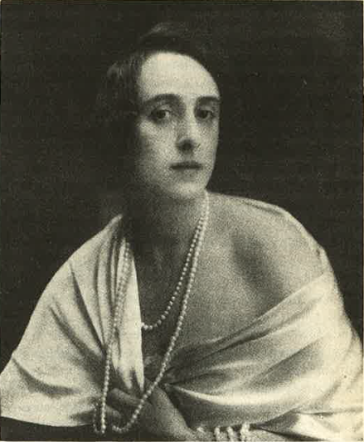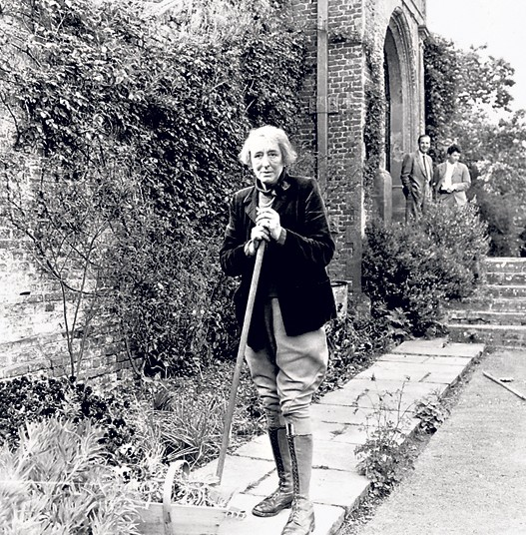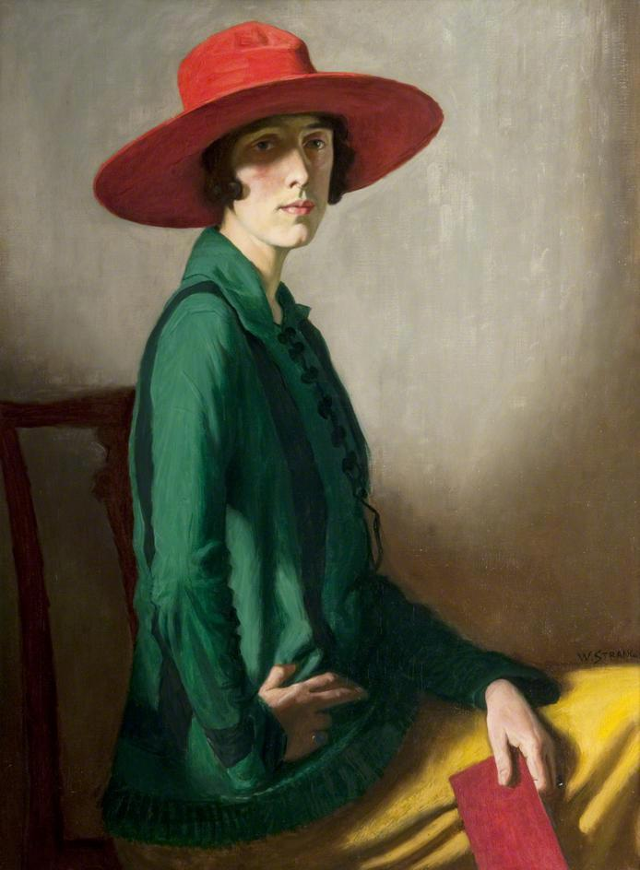Vita Sackville-West was a poet, prose writer and gardener. Much of her work was significantly informed by her close identification with the English landscape, in particular her ancestral home Knole, and Sissinghurst Castle in Kent where she lived from 1930. She is the only author to have won the Hawthornden literary prize twice, first for her long poem *The Land* (1926), and then for her *Collected Poems* (1933). Her best-known novels are *The Edwardians* (1930) and *All Passion Spent* (1931). She also wrote two classic pieces of travel writing on Iran, *Passenger to Teheran* and *Twelve Days: An Account of a Journey across the Bakhtiari Mountains of South-western Persia* (1926 and 1927) based on her visits to and travel with her husband Harold Nicolson, a diplomat; her biographical publications include works on Joan of Arc and Aphra Behn. She is now best known as the model for the eponymous hero/heroine of Virginia Woolf’s 1928 novel *Orlando*, a work described by Sackville-West’s son Nigel Nicolson as ‘the longest and most charming love-letter in literature’, although in her lifetime she was a more popular writer than WOOLF.

Sackville-West working in the gardens at Sissinghurst.

url: <http://www.telegraph.co.uk/gardening/9347117/Vita-Sackville-West-her-passions-in-pictures.html>, copyright Southeby’s

This portrait of Vita Sackville-West was painted by the Scottish artist William Strang in 1918.

url: <http://books0977.tumblr.com/post/24451920036/vita-sackville-west-as-lady-in-a-red-hat-1918> held in Glasgow Museums collection so copyright probably with them.

Sackville-West, Vita, Harold Nicolson and Nigel Nicolson (1992) *Vita and Harold: The Letters of Vita Sackville-West and Harold Nicolson*, *1910-62,* London: Weidenfeld & Nicolson.

**Selected list of works**

**Poetry**

*Poems of West and East* (1917)

*The Land* (1926)

*Sissinghurst* (1931)

*Collected Poems* (1933)

*Selected Poems* (1941)

*The Garden* (1946)

**Novels**

*Heritage* (1919)

*Challenge* (1923)

*Seducers in Ecuador* (1924)

*The Edwardians* (1930)

*All Passion Spent* (1931)

*The Dark Island* (1934)

*Grand Canyon* (1942)

*No Signposts in the Sea* (1961)

**Biographies/Other works**

*Knole and the Sackvilles* (1922)

*Passenger to Teheran* (1926)

*Aphra Behn* (1927)

*Saint Joan of Arc* (1936)

*Twelve Days: an account of a journey across the Bakhtiari Mountains of South-western Persia* (1927)

**Further reading**

Brown, Jane (1985) *Vita's other world: a gardening biography of V. Sackville-West*, London: Viking.

Glendinning, Victoria (1983) *Vita: the life of V. Sackville West*, London: Weidenfeld & Nicolson.

Nicolson, Nigel, and Vita Sackville-West (1973) *Portrait of a Marriage,* London: Weidenfeld & Nicolson.

Sackville-West photographed as ‘Orlando on her return to England’ by Lenare in 1927. The photograph was one of several appearing in Woolf’s pseudo-biography, including two others of Sackville-West.

(This is scanned from my own copy of *Orlando*, hence the not brilliant quality. I could only find this version online: <http://www.smith.edu/libraries/libs/rarebook/exhibitions/images/penandpress/large/11a_orlando_gaige.jpg>)

Raitt, Suzanne (1993) *Vita and Virginia: The Work and Friendship of V. Sackville-West and Virginia Woolf*, Oxford: Oxford University Press.

Bryony Randall, University of Glasgow